# Department of Computer Engineering

**Academic Term: July-November 2023**

# Rubrics for Lab Experiments

|  |  |  |
| --- | --- | --- |
| **Class** | **: B*.E. Computer*** | **Subject Name :*BDA*** |
| **Semester** | **: VII** | **Subject Code :** |

|  |  |
| --- | --- |
| **Practical No:** | 6 |
| **Title:** | Write a command  to perform insert, create, update and delete Cassandra (NoSQL) database. |
| **Date of Performance:** | 17-8-23 |
| **Roll No:** | 9427 |
| **Name of the Student:** | Atharva Prashant Pawar |

**Evaluation:**

|  |  |  |  |  |  |
| --- | --- | --- | --- | --- | --- |
| **Performance**  **Indicator** | **Below average** | **Average** | **Good** | **Excellent** | **Marks** |
| **On time Submission (2)** | Not submitted(0) | Submitted after deadline (1) | Early or on time submission(2) | --- |  |
| **Test cases and** | Incorrect | The expected | The expected | Expected output is |  |
| **output** | output (1) | output is | output is Verified | obtained for all test |
| **(4)** |  | verified only a | for all test cases | cases. Presentable and |
|  |  | for few test | but is | easy to follow (4) |
|  |  | cases (2) | not presentable (3) |  |
| **Coding** | The code is not | The code is | The code is | - |  |
| **efficiency (2)** | structured at all | structured but | structured |  |
|  | (0) | not efficient (1) | and |  |
|  |  |  | efficient. (2) |  |
| **Knowledge(2)** | Basic concepts not clear  (0) | Understood the basic concepts (1) | Could explain the concept with  suitable example (1.5) | Could relate the theory with real world  application(2) |  |
| **Total** |  | | | | |

Signature of the Teacher :

Aim: Write a command to perform insert, create, update and delete Cassandra (NoSQL) database

* **Understand NoSQL databases architecture**
* **Understand commands to create database using cassendra**
* **Understand commands to insaert data using cassendra**
* **Understand commands to update data using cassendra**
* **Understand commands to delete data using cassendra Steps for creating database:**

Using Docker run Cassandra commands:

Commands for simple database creation:

1. **Sudo apt install docker.io**
2. **sudo docker pull Cassandra:latest**
3. **sudo docker run –d --name cassandra-node –p 9042:9042 cassandra (note: 9042 port reserverd for Cassandra)**
4. **sudo docker exec –it cassandra-node bash**
5. **cqlsh (note: cqlsh-&gt;Cassandra query language shell)**
6. **create keyspace test with replication={‘class’: ‘SimpleStrategy’, ‘replication_factor’:1};**

(note:keyspace means database,here name of database is test) 7.use test;

1. **create table student(s_id int primary key,s_name text,s_city text);**
2. **insert into student(s_id,s_name,s_city)values(1,’ABCD’,’Mumbai’);**

9. insert into student(s_id,s_name,s_city)values(2,’PQRS’,’Punei’); 10.select * from student;

Create and Insert Operation :

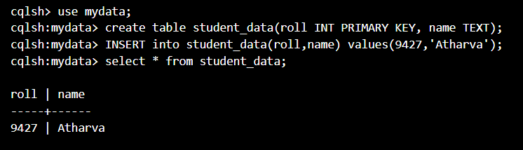

Update Operation :

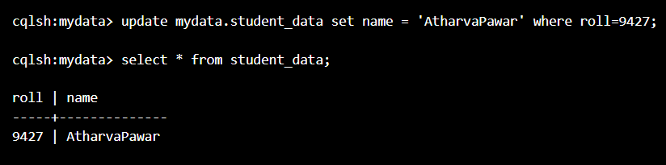

Delete Operation:

